Task 3:

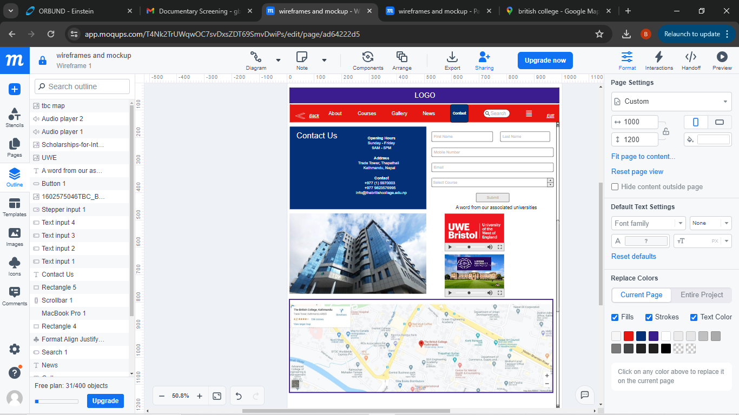

Here, I have tried to modify the colours to the national flag of England and keep the theme as much related to the flag as the college is named after the country itself.

Task 2:

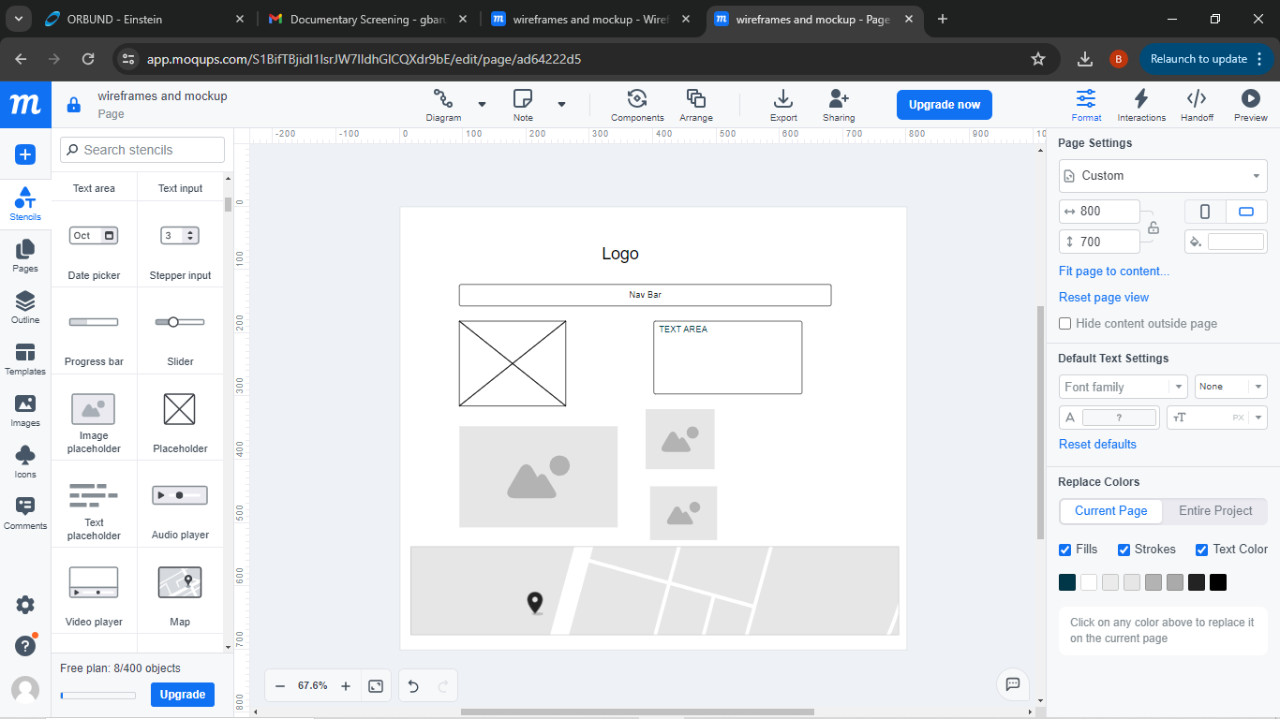

Task 1:

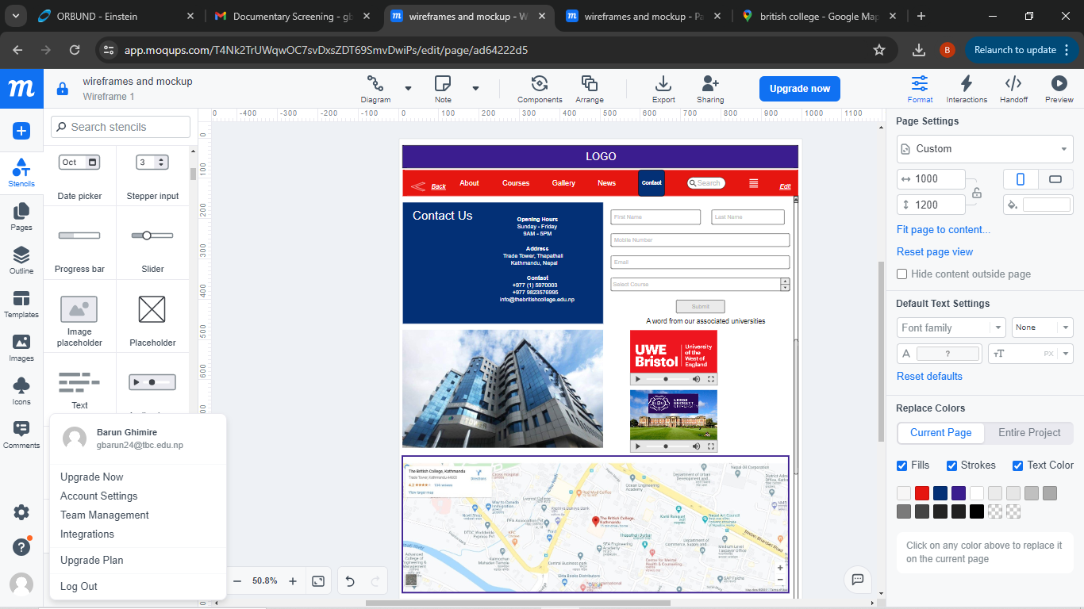

Submitted By: Barun Ghimire(Bsc.Hons Artificial Intelligence)

To : Aashish Acharya Sir